Summer Vacation Project
- Pick three resorts that you might possibly want to visit. Write their names here:

____________________ ___________________ ____________________

- For each resort find out the following information:
  - How many guest rooms are there?
  - What are a few activities that they offer on the resort site?
  - How many restaurants are on site?

Resort #1: _______________ | Resort #2: _______________ | Resort #3: _______________

3. Sketch a simple map of each resort. Be sure to include (the resort building, the pool area, activity areas if any (tennis, etc))

- Pick one of the resorts that you researched. You will now create a brochure on this resort.
- Visit a travel website that does NOT require you to sign up for an account. NEVER sign up for any account or enter ANY personal information. You will need to find a flight from New York (Laguardia airport, John F Kennedy airport, Mac Arthur airport, or Newark airport) to your destination.
- Visit either a travel website that does not require you to sign up for an account or the resort website. Again, NEVER enter ANY personal information. You will be staying at your resort for 6 nights and 7 days in July of 2020. Pick specific dates and price out the hotel.
- Find 3 activities that you would like to do while vacationing. Research these activities (what are you going to do, how long is it, how much does it cost).
Inside Panel  - Include all of the information about your flight.  - What airport are you flying out and into?  - What time is your outgoing flight?  - How long is the flight?  - Is the flight direct or are there stops?  - What time will you arrive at your final destination?  - What airline are you flying with?  - What time is your flight to go home?  - How long is the flight?  - Is the flight direct or are there stops?  - What time will you arrive in New York?  - What airline are you flying with? | BACK  - How many restaurants are located on site at the resort?  - Name each restaurant, include a photo, and a short description of the type of food that is offered. | COVER  - Name of resort  - Location of resort (for example, Aruba or Hawaii)  - A photo of the resort  - Our names

Inside Panel  - What are the dates of your stay?  - What type of room are you staying in? Include two photos  - What are some special features included in the room (kitchen, microwave, refrigerator, Jacuzzi tub, etc).  - How much will the room cost for the 6 nights and 7 days? | Inside Panel  - Describe the three activities that you chose to participate in while vacationing. You need a description of each activity, a photo, and the cost. | Inside Panel  - Include a map of the resort on this page.  - Why would you like to visit this resort?

PART II
You are going to create a map of your dream resort. Your map must include
- A building that includes the guest rooms
- A pool area
- Three different activities on the property (examples, tennis, kids center)
- Three different restaurants with a description on what they offer

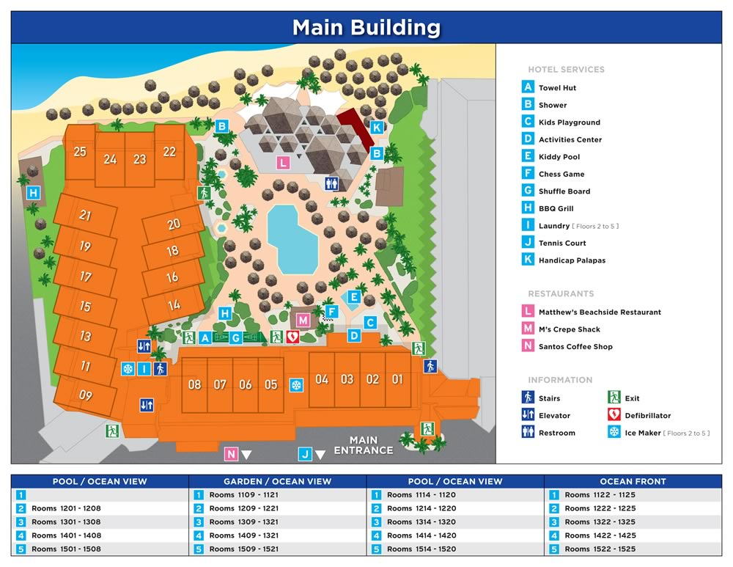
 | 3 | 2 | 0
Panel 1 | All aspects are included | One aspect is missing | More than one aspect is missing
Panel 2 | All aspects are included | One aspect is missing | More than one aspect is missing
Panel 3 | All aspects are included | One aspect is missing | More than one aspect is missing
Panel 4 | All aspects are included | One aspect is missing | More than one aspect is missing
Panel 5 | All aspects are included | One aspect is missing | More than one aspect is missing
Panel 6 | All aspects are included | One aspect is missing | More than one aspect is missing

